   

### **PROJECT TITLE : CREATION OF AN APPLICATION FOR SCHOOL MANAGEMENT – ADMIN**

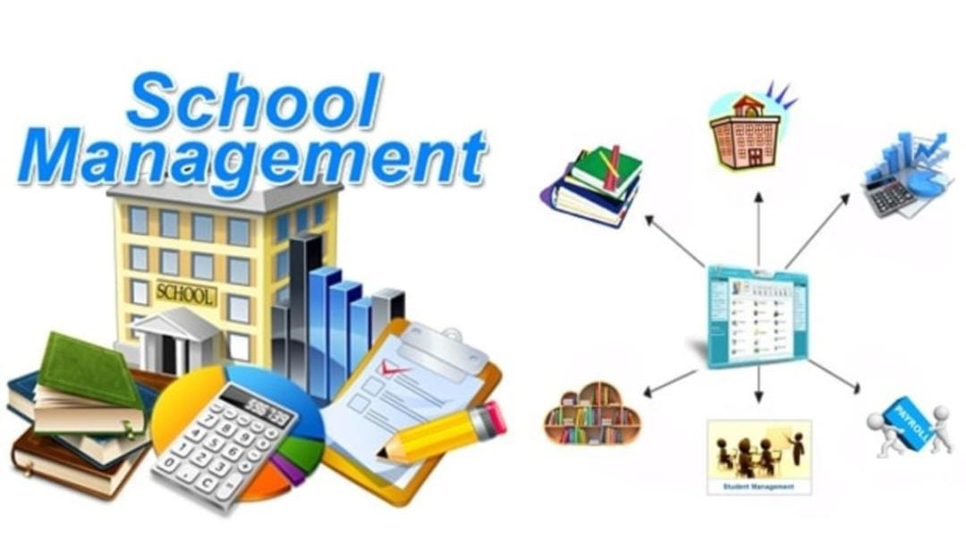

# Presented by

## 

## Team Id: LTVIP2023TMID06123

Team Leader: Shaik Ruksana ([208x1a05g1@khitguntur.ac.in](mailto:208x1a05g1@khitguntur.ac.in))

Team Member 1: Balineni Srilakshmi([208x1a05c8@khitguntur.ac.in](mailto:208x1a05c8@khitguntur.ac.in))

Team Member 2: Kambhampati Akhil([208x1a05e7@khitguntur.ac.in](mailto:208x1a05e7@khitguntur.ac.in))

Team Member 3: Maddu Ramya ([208x1a05f2@khitguntur.ac.in](mailto:208x1a05f2@khitguntur.ac.in))

Team Member 4: Chalamalasetty Keerthana([208x1a05d6@khitguntur.ac.in](mailto:208x1a05d6@khitguntur.ac.in))

Team Member 5: Rentapalla Vamsi ([218x5a0208@khitguntur.ac.in](mailto:218x5a0208@khitguntur.ac.in))

Our Trailblazer accounts

*Name* Profile Id

1.Shaik Ruksana - <https://www.salesforce.com/trailblazer/s208x1a05g1>

2.Balineni Srilakshmi - <https://www.salesforce.com/trailblazer/s208x1a05c8>

3.Kambhampati Akhil - <https://www.salesforce.com/trailblazer/akambhampati5>

4.Maddu Ramya - <https://www.salesforce.com/trailblazer/s208x1a05f2>

5.Chalamalasetty Keerthana - <https://trailblazer.me/id/s208x1a05d61>

6.Rentapalla Vamsi - <https://www.salesforce.com/trailblazer/s218x5a0208>

INTRODUCTION

**Overview:**

Salesforce, Inc. is an American cloud-based software company headquartered in San Francisco, California. It provides customer relationship management (CRM) software and applications focused on sales, customer service, marketing automation, e-commerce, analytics, and application development. Founded by former Oracle executive Marc Benioff, Salesforce quickly grew into one of the largest companies in the world, making its IPO in

2004. Salesforce's continued growth makes it the first cloud computing company to reach US$1 billion in annual revenue by fiscal year 2009, and the world's largest enterprise software firm by 2022. Salesforce was 0 executive Marc Benioff, together with Parker Harris, Dave Moellenhoff, and Frank Dominguez as a software as a service (SaaS) company. Two of Salesforce's earliest investors were Larry Ellison, the co-founder and first CEO of Oracle, and Halsey Minor, the founder of CNET.

**Salesforce Services**:

Salesforce offers several customer relationship management (CRM) services, including Sales Cloud, Service Cloud, Marketing Cloud, and Commerce Cloud and Platform. Additional technologies include Slack.

**Main services**:

Salesforce's main services are for customer management. Other services include app creation, data integration and visualization, and training… **Salesforce Platform**:

Salesforce Platform (formerly known as Force.com) is a platform as a service (PaaS) that allows developers to add applications to the main Salesforce.com application. These applications are hosted on Salesforce.com's infrastructure. Force.com applications are built using Apex, a proprietary Java-like programming language to generate HTML originally via the "Visualforce" framework. Beginning in 2015 the "Lightning Components" framework has been supported. As of 2014, the Force.com platform had 1.5 million registered developers according to SalesForce.

**Trailhead**:

Launched in 2014, Trailhead is a free online learning platform with courses focused on Salesforce technologies.

**AppExchange**:

Launched in 2005, the Salesforce AppExchange is an online app store that allows users to sell third-party applications and consulting services.

**Overview**: **School Management Project**

A school management system is an information management system for educational institutions to manage student data. It helps teachers get information about students faster, easier and reduces their workload. Student databases in school management systems contain information about the students, such as their exam grades, parent information, medical history, tuition fees, etc. School management systems provide skills such as student registration, class documents, grades, analytical grades for students, and other assessment elements. In addition, school management systems are used to plan the curriculum of students, record their presence and manage the needs of students in the school. School management solutions are web and mobile-based applications with centralized data storage structures that make it easier for administrators, students, teachers, and parents to access data from iPhone and Android devices.

There are various software tools you can use to automate your organization to achieve your goals and take advantage of digitalization in operation, and school management software is an integral part of every school or college. The school management software consists of several modules that manage the entire school life cycle that includes:

* Student enrollment.
* School activities.
* Fees collection.
* Student’s reports.
* Transportation.
* Libraries

In our School Management Project, first our team members will be created three different objects called School, Student and Parent for web interface for everyone who accessed the School Management Service in the site. Second our team members will be created School fields, Student Fields and Parent fields to be filled information in future. Next, our team members will be created school profile (e.g standard user). Next, we should create three users such as parent, teacher and principal. Next, we will be created permission sets such as read, edit, created for principal, Parent, school, student objects. Next, we will add data to student object. Finally, we will created, saved, viewed and deleted various reports.

**Purpose:**

1.The project aims to develop an application for school management that automates administrative tasks, enhancing efficiency and reducing manual effort.

2.It centralizes student, teacher, and staff information, ensuring better data management and accuracy in records.

3.The application fosters seamless communication between teachers, parents, students, and administrators through announcements and notifications.

4.It simplifies attendance tracking, academic performance monitoring, and examination/result management for teachers and administrators.

5.The application provides valuable reports and analytics to aid data-driven decision-making for improved school performance and resource management.

LITERATURE SURVEY

**Existing Problem**:

1.The existing problem with the creation of an application for school management is the lack of a unified and efficient system to handle various administrative tasks.

2.Many schools still rely on manual processes, spreadsheets, and disparate software, leading to inefficiencies, data inconsistencies, and communication gaps.

3.This fragmented approach often results in difficulties in tracking attendance, managing student information, generating accurate reports, and ensuring smooth communication among teachers, parents, and administrators.

4. The absence of a comprehensive and user-friendly school management application hampers the overall efficiency and effectiveness of school operations.

**Proposed Solution:**

1.The proposed solution to suggest is to develop a comprehensive cloud-based school management application with an intuitive interface, automation features, and seamless integration.

2. It will facilitate efficient attendance tracking, academic management, and communication among teachers, parents, students, and administrators.

3. The application will provide valuable insights through analytics and reports, ensuring data-driven decision-making.

4. With robust security measures and customization options, schools can enhance overall efficiency and productivity, creating a more streamlined and effective learning environment.

THEORITICAL ANALYSIS

**Block Diagram:**

Diagrammatic Overview of the project:

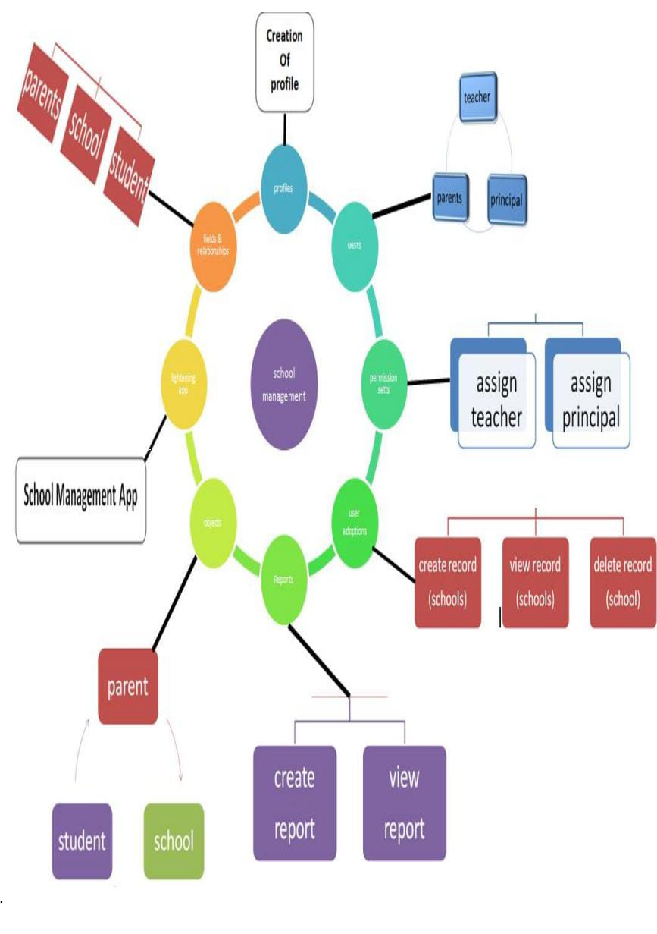

**Hardware and Software Designing:**

In the Salesforce platform, the School Management Application would be developed as a cloud-based software solution, which means most of the hardware requirements would be taken care of by Salesforce itself. However, there are still some essential hardware and general requirements to consider:

**Hardware requirements of the project**:

**Memory (RAM)**

* 8 GB RAM
* 16 GB RAM if the access node also hosts the database

**Processor**

* Minimum of 8 CPUs/processors.

**Software requirements of the project**:

**Browsers**

* Google Chrome
* Safari
* Mozilla Firefox
* Microsoft Edge

**Mobile and Desktop Operating Systems**

* Mac: macOS 10.14 (Mojave) or later
* Windows: Windows 7 or later
* iOS: iOS 13 or later
* Android: Android 5.0 (Lollipop) or later

PROCESS AND RESULTS

Final findings (Output) of the project along with screenshots.

**1.Creating Developer Org:**

Creating a developer org in salesforce

1. Go to [developer.salesforce.com](https://developer.salesforce.com/)

b. Click on sign up.

c. On the sign up form, enter the following details

1. First name & Last name
2. Email
3. Role – Administrator
4. Company - College Name
5. Country – India
6. Postal Code - pin code
7. Username- should be a combination of your name and company

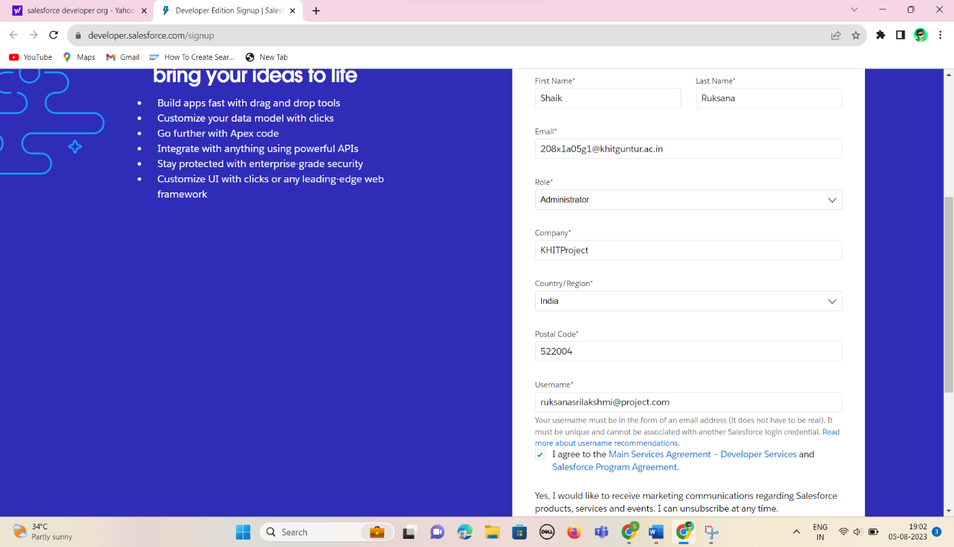

2.**Account Activation**:

We have to verify our email to activate the account. So, click on verify account to activate the Salesforce Account

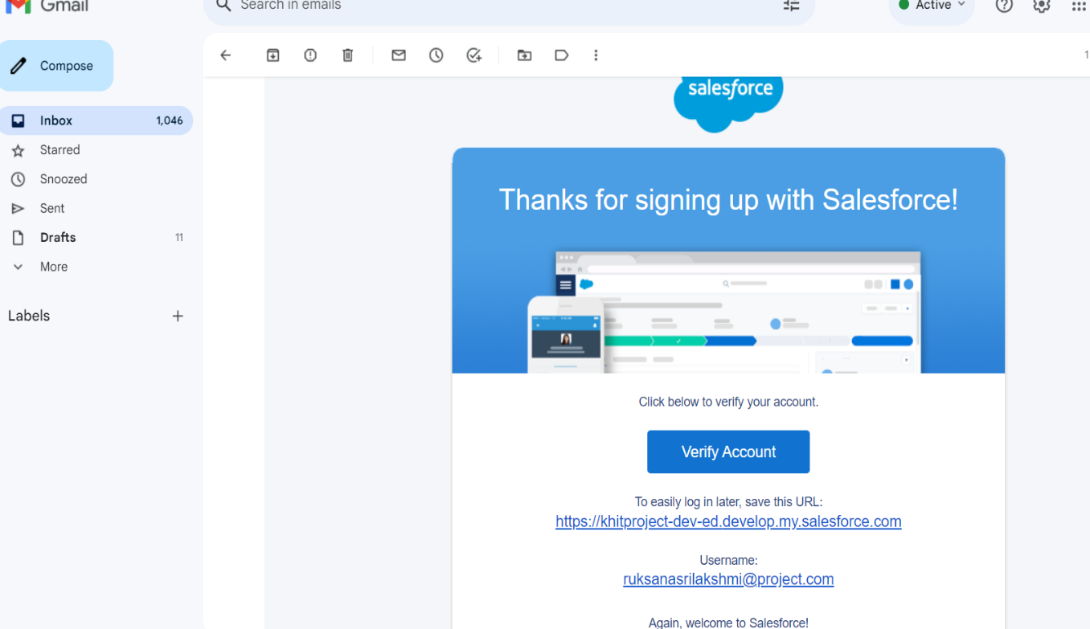

After verifying, it asks to set up the password including a security question like below:

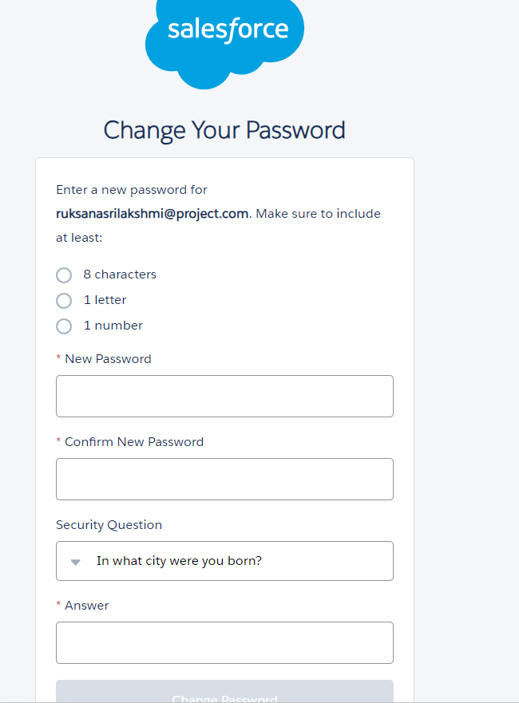

After setting the password, the page redirects to the Salesforce Setup Page where we are going to do each and every step regarding our project. It looks like this.



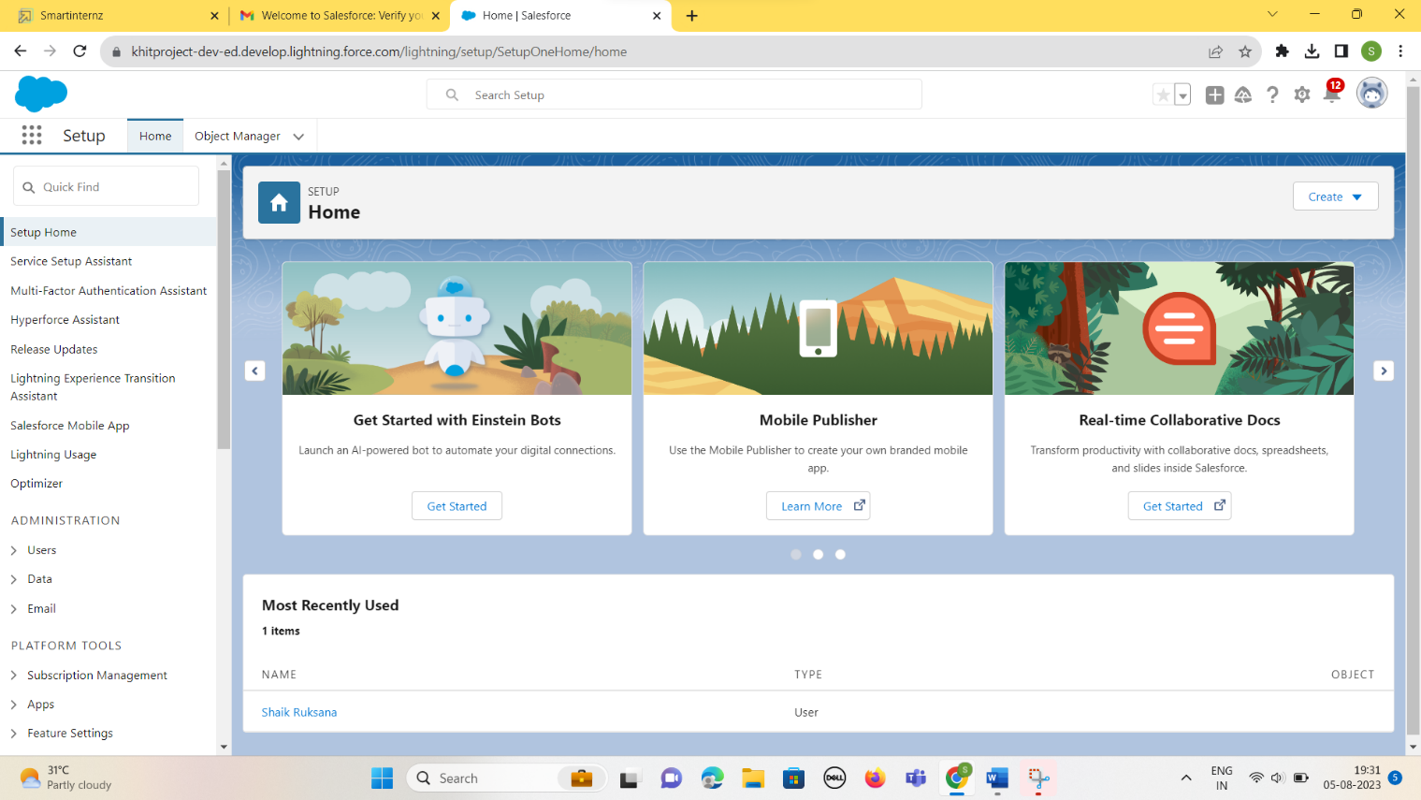



Here's a brief introduction to the key components of the Salesforce setup page:

1.Home: The central hub for Salesforce administrators to access and manage all setup options.

2.Object Manager: Customize and manage standard and custom objects, defining data structure and relationships.

3.App Launcher: Easily switch between Salesforce apps and custom-built applications.

### **3.OBJECT**

Salesforce objects are database tables that permit you to store data that is specific to an organization. Salesforce objects are of two types:

* Standard Objects: Standard objects are the kind of objects that are provided by salesforce.com such as users, contracts, reports, dashboards, etc.
* Custom Objects: Custom objects are those objects that are created by users. They supply information that is unique and essential to their organization. They are the heart of any application and provide a structure for sharing data.

**Coming to our project we have to create three custom objects:**

1.School Object

2.Student Object

3.Parent Object

Goto Object Manager and select Custom Object New and Create three objects

First Object – School

1. Label: School
2. Plural Label: Schools
3. Record Name: School Name
4. Check the Allow Reports checkbox
5. Check the Allow Search checkbox
6. Click Save.

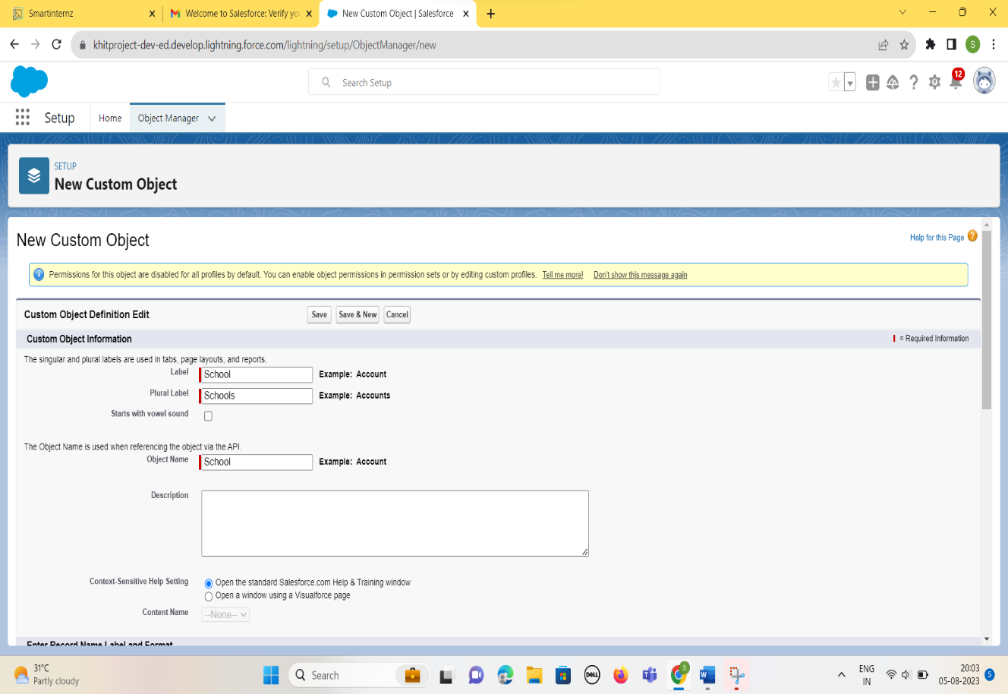

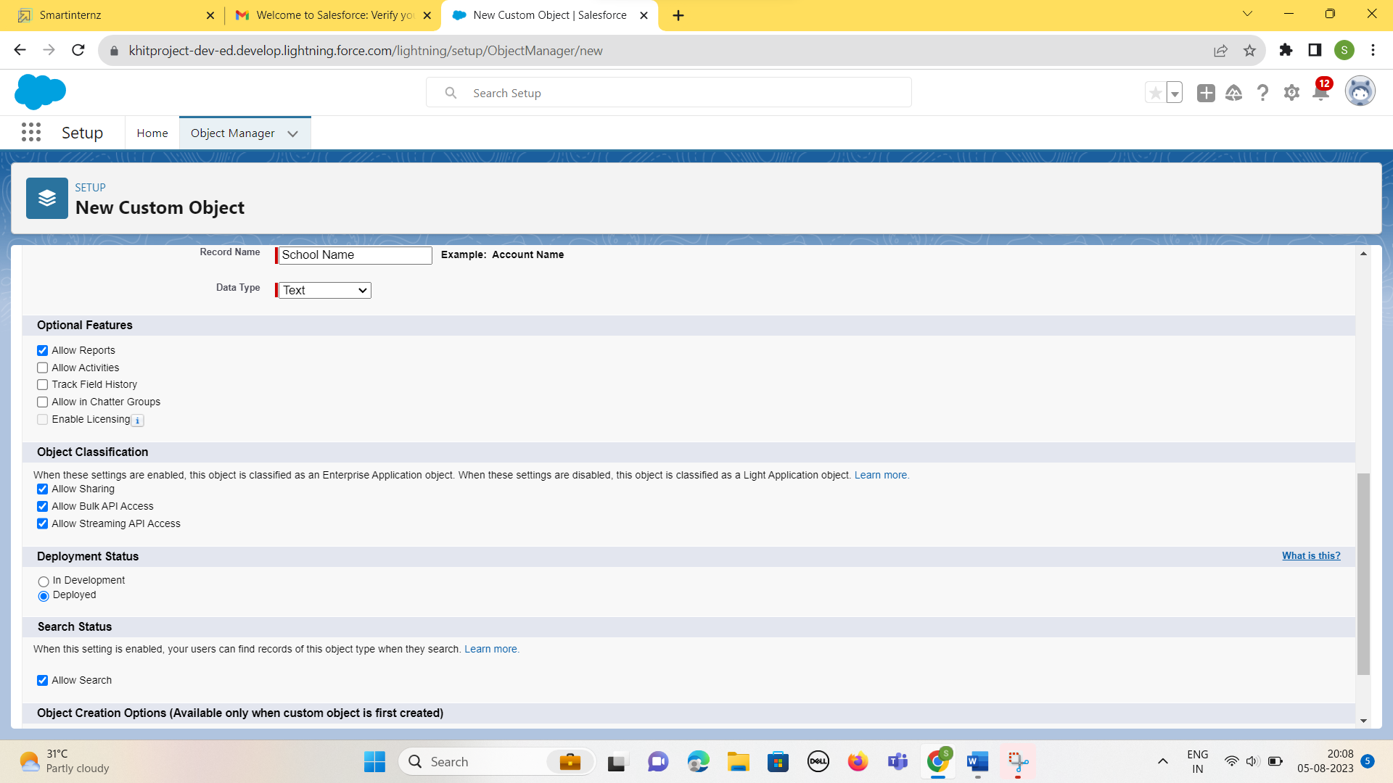

Now create a custom tab. Click the Home tab.

Search for Tabs Then Click it -🡪 Custom Tab🡪 New

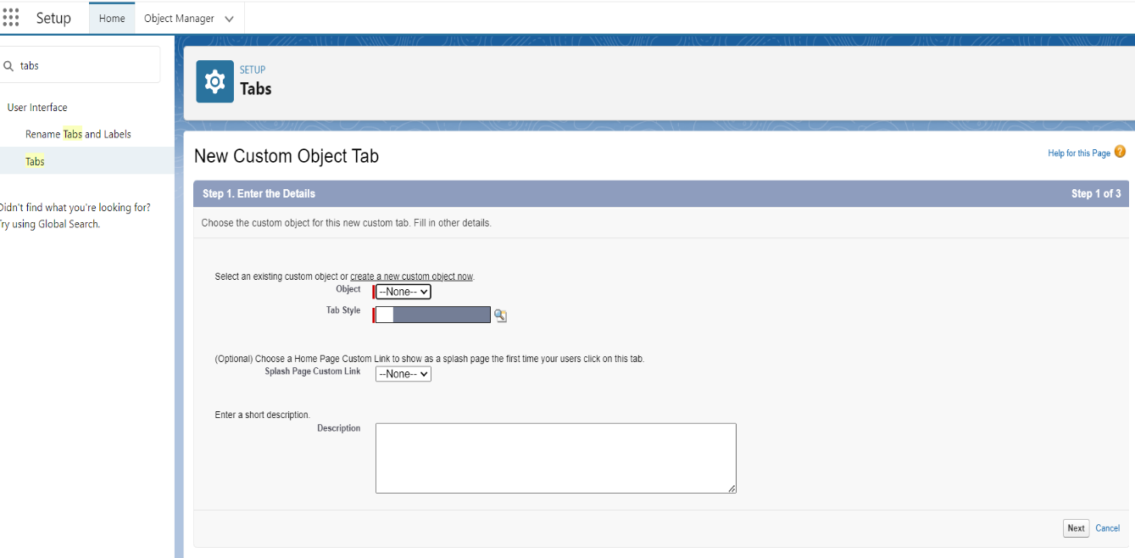

Select Object as School. And any Tab style. Click Next, Next and then Save. It looks like this.

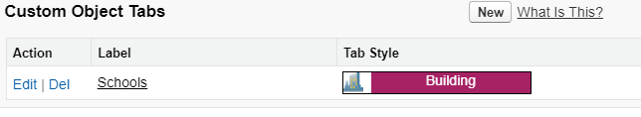

In the same way, we created the two Custom objects like Student Object and Parent Object and their respective tabs as below:

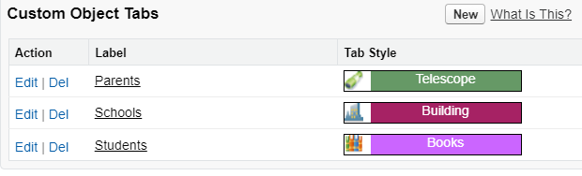

### **4.Creating the Lightning App**

Apps in Salesforce are a group of tabs that help the application function by working together as a unit. It has a name, a logo, and a particular set of tabs. The simplest app usually has just two tabs.  
There are two types of app -  
 ***1. Standard App***: Standard apps come with every occurrence of Salesforce as default. Many features like Sales, Marketing, Community, call center, content, Salesforce Chatter, App Launcher, etc are present in it.

***2.Custom Apps***: Custom apps are created according to need of user. Custom Apps are made by using standard and custom tabs together.

1. From Setup, enter App Manager in the Quick Find and select App Manager.  
2. Click New Lightning App.  
3. Enter School Management as the App Name, then click Next  
4. Under App Options, leave the default selections and click Next.  
5. Under Utility Items, leave as is and click Next.  
6. From Available Items, select Schools, Students, Parents, Reports, and Dashboards and move them to Selected Items. Click Next.  
7. From Available Profiles, select System Administrator and move it to Selected Profiles.Click Save & Finish.

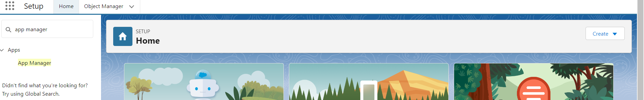

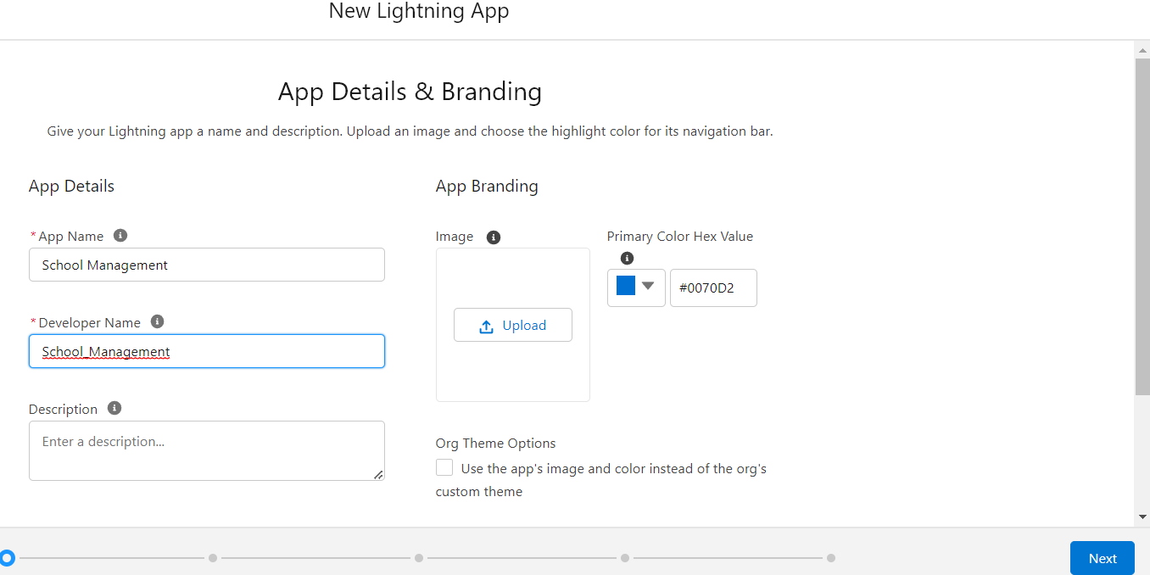

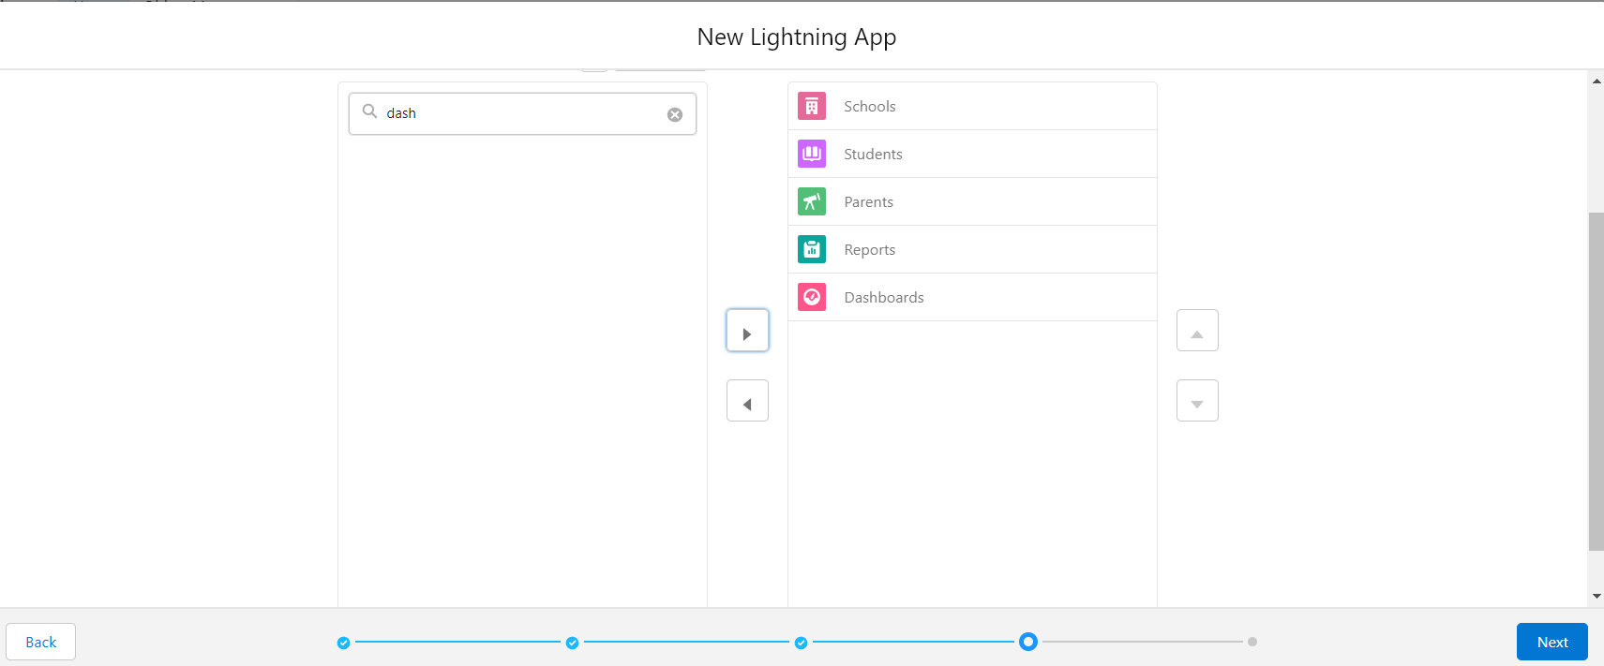

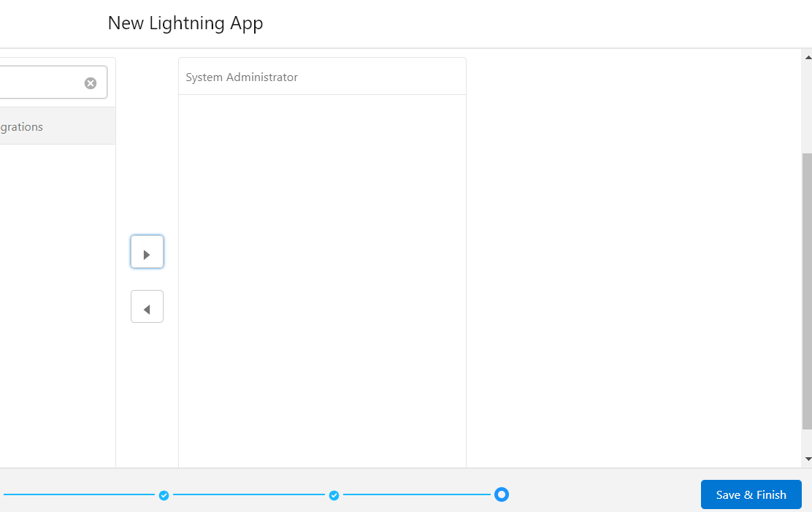



If we want to check the app we have created .Goto App Launcher🡪Search for the School Management App🡪Click it. The App looks like this.



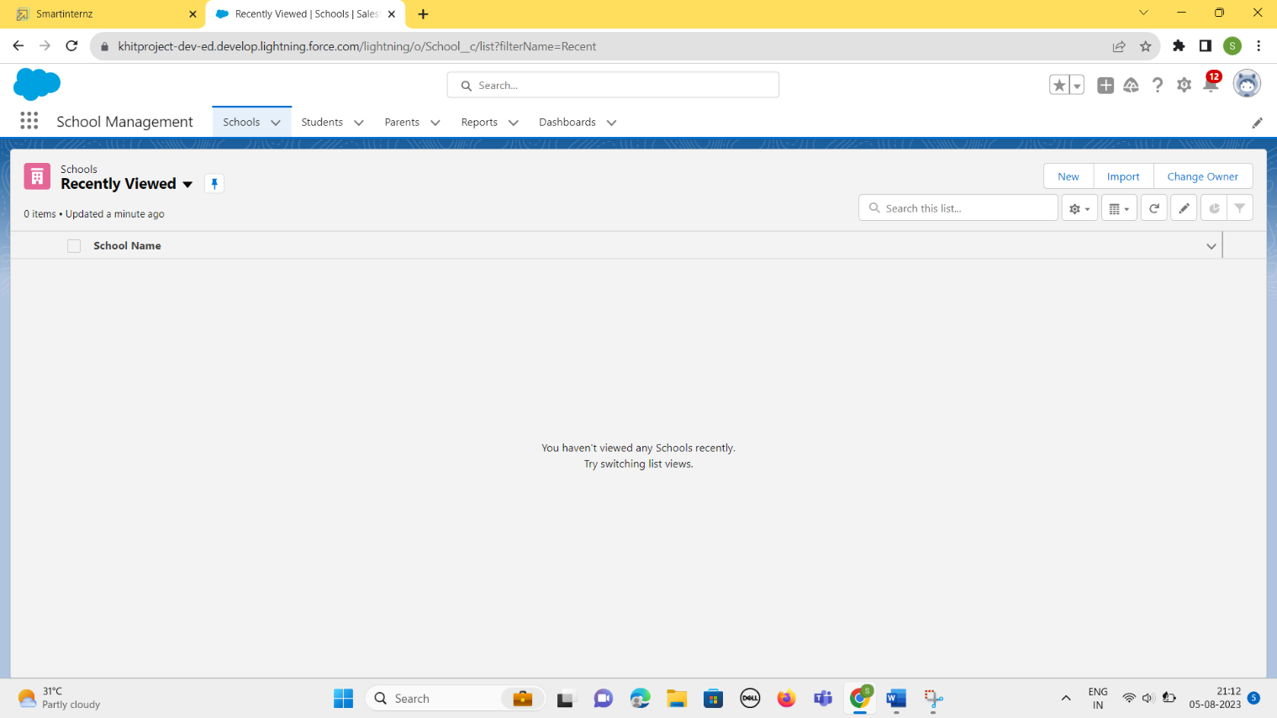

### **5.Fields and Relationship**

An object relationship in Salesforce is a two-way association between two objects. Relationships are created by creating custom relationship fields on an object. This is done so that when users view records, they can also see and access related data.

### Creation Of Fields for The School Object:

1. Click the gear icon and select Setup. This launches Setup in a new tab.  
   2. Click the Object Manager tab next to Home.  
   3. Select School.  
   4. Select Fields & Relationships from the left navigation  
   5. Click New  
   6. Select the Text Area as the Data Type, click Next.  
   7. For Field Label, enter Address.  
   8. Click Next, Next, then Save & New.  
   9. Follow steps 1 to 3 and create two more Text type field - District & State.  
   10. Create URL type field & give School website as the field label.

We have to create 5 fields for the School Object. They are – *Address, District, State*, *Phone, URL* with their respective Relationships.

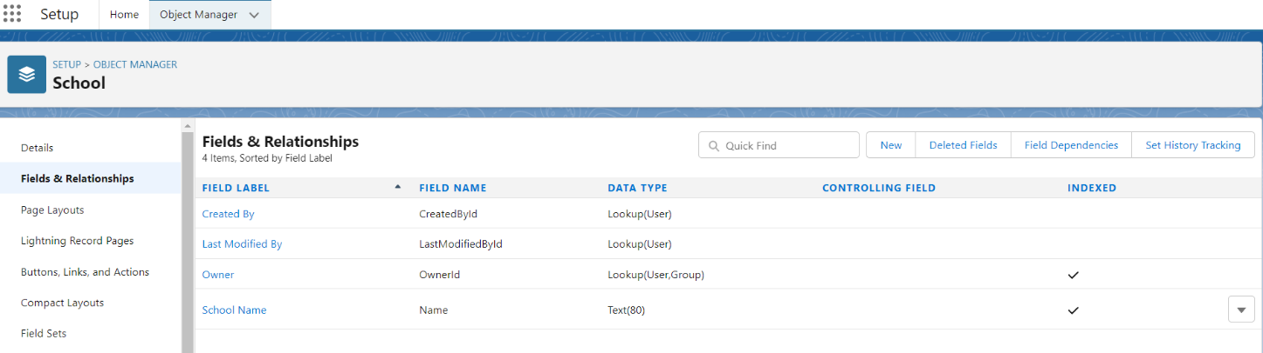

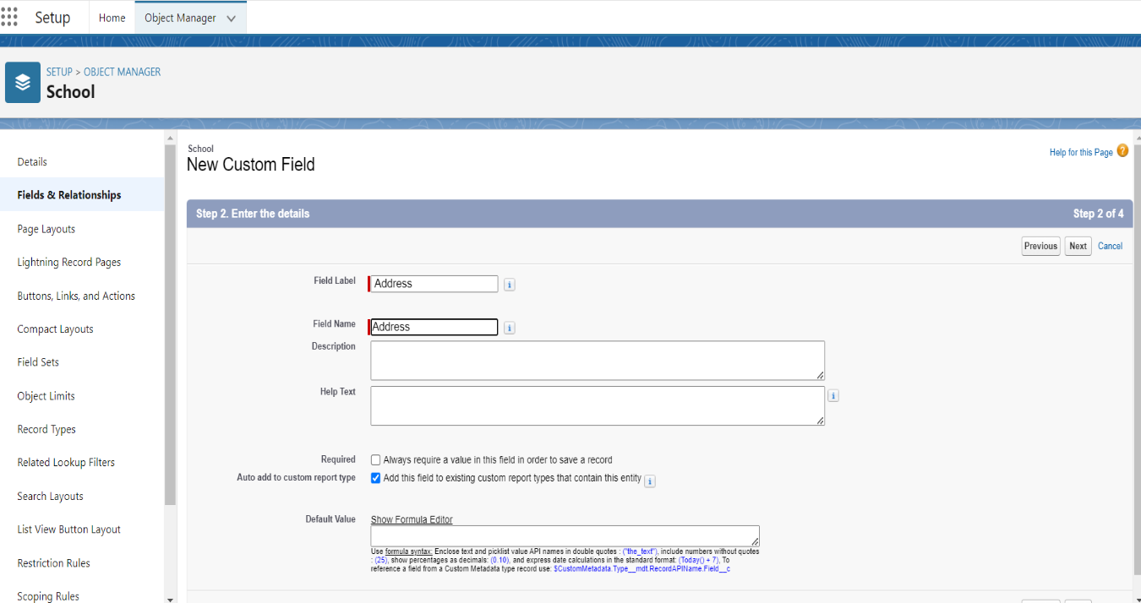

After creating all the required fields for the School Object

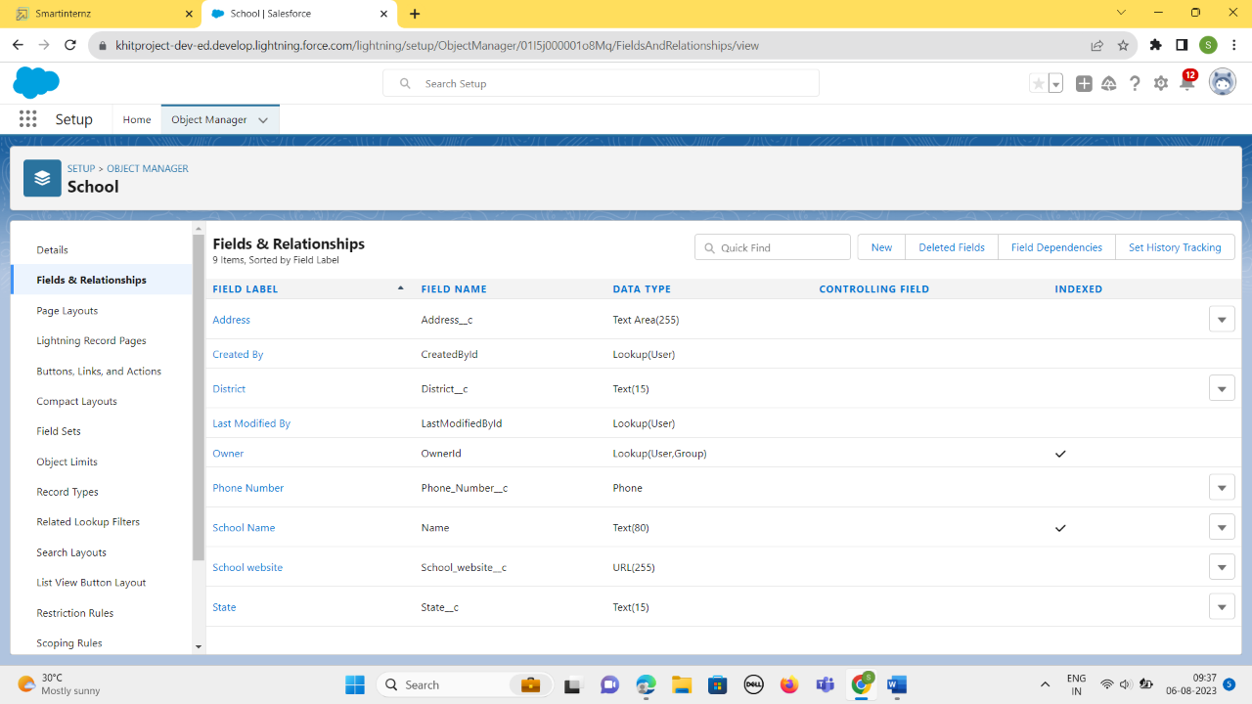



### *Creation Of Fields for The Student Objects*:

Field 1 – *Results* and Relationship is of Picklist type and we have to enter the picklist values as Pass, Fail.

Field 2- *Class* and Relationship is of Number type

Field 3- *Marks* and Relationship is of Number type

Field 4- *Number of Students* and Relationship is of Roll-up Summary type

After creating the required above fields looks like this

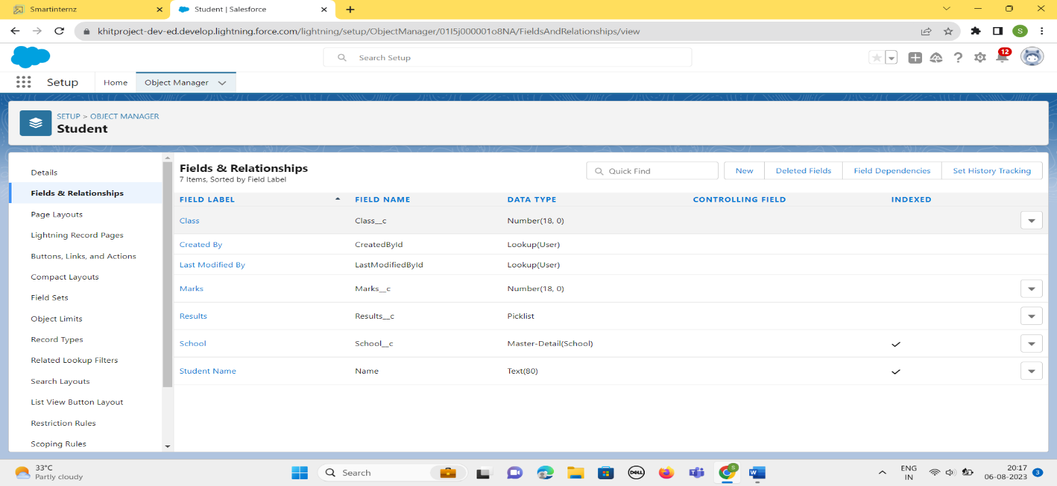

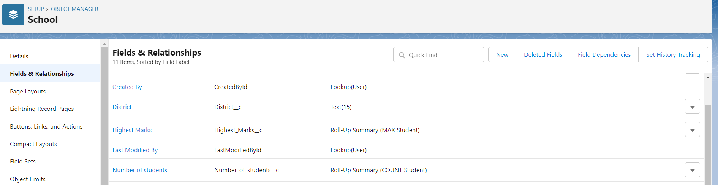

### *Creation Of Fields for The Parent Objects:*

We have to create 2 fields :

Field1 – *Parent Address* and relationship is of Text area

Field2- *Parent Number* and relationship is of Phone.

After creating the above two fields, it looks like this:

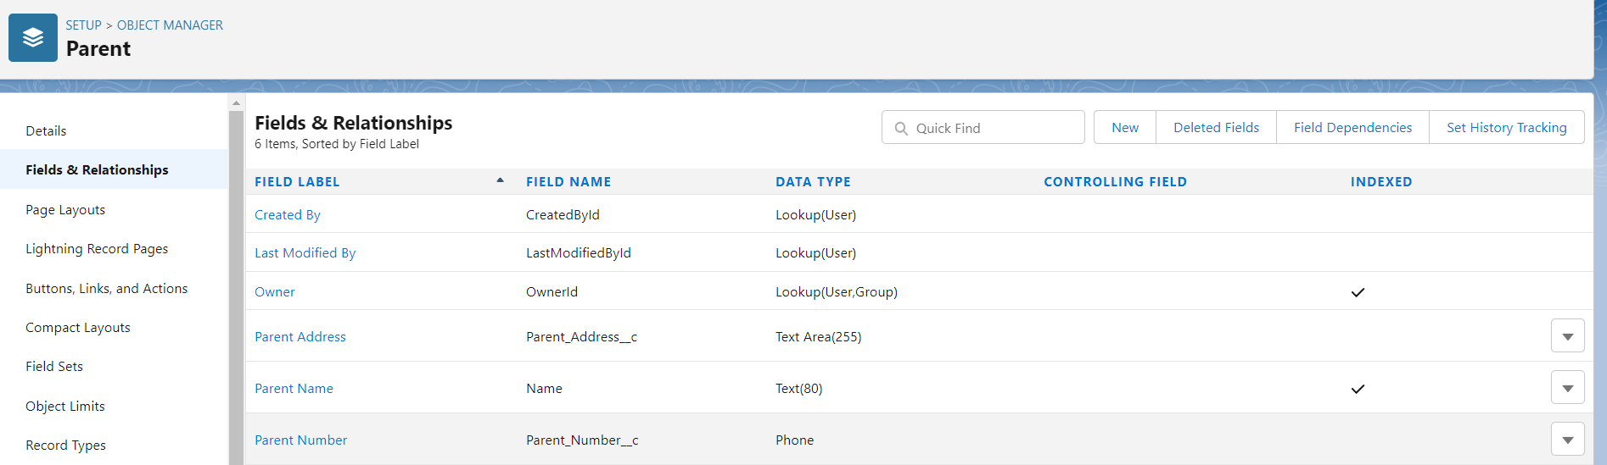

### **6.Profile**

A profile is a group/collection of settings and permissions that define what a user can do in salesforce. A profile controls “Object permissions, Field permissions, User permissions, Tab settings, App settings, Apex class access, Visualforce page access, Page layouts, Record Types, Login hours & Login IP ranges.

### Creation On Profile:

1.From Setup enter Profiles in the Quick Find box

2.Select Profiles.

3.Click new, From the list of profiles, find Standard User (profile to clone)

4.For Profile Name, enter School Profile

5.Click Save.

6.While still on the School Profile page, then click Edit.

7.Scroll down to Custom Object Permissions and Give view all access permissions.

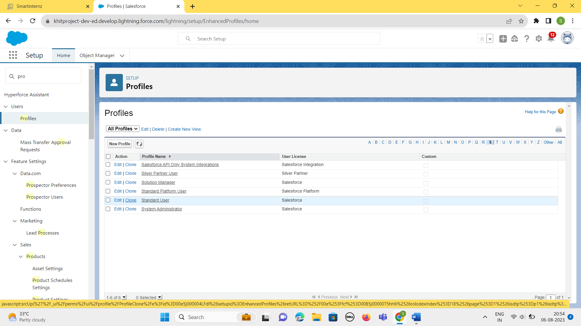



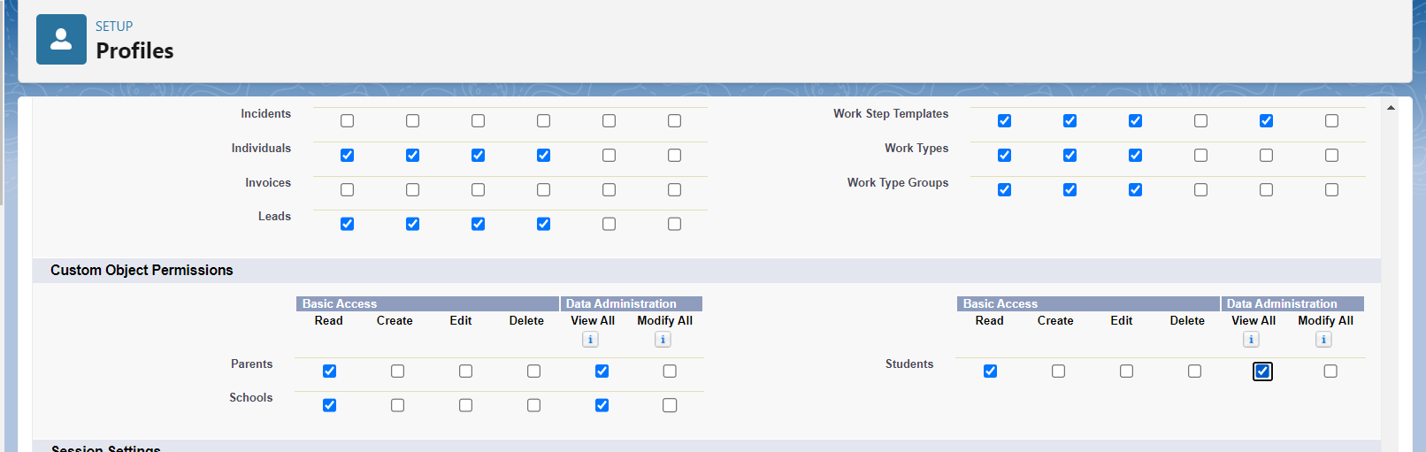

The “School Profile” is created as below:

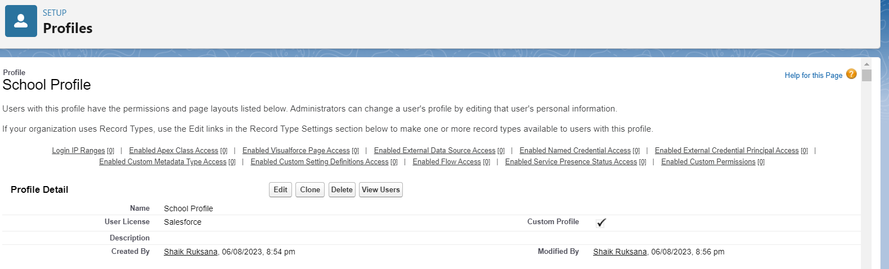

### **7.Users**

A user is anyone who logs in to Salesforce. Users are employees at your company, such as sales reps, managers, and IT specialists, who need access to the company's records. Every user in Salesforce has a user account.

### Creating A User:

1.From Setup, in the Quick Find box, enter Users.

2.Select Users.

3. Click New User.

4. Enter the user’s name Parents and (Your) email address and a unique username in the form of an email address. By default, the username is the same as the email address.

5. Select a User License as salesforce.

NOTE- As Salesforce license can only be used by 2 Users at a time in Dev Org, so If you don’t find salesforce license then deactivate a user who has salesforce license or change the license type from Salesforce to any other.

6.Select a profile as a School Profile.

7. Check Generate new password and notify the user immediately to have the user’s login name and a temporary password emailed to your email.

8. Similarly follow the above steps and create 2 users as Teachers and principals.

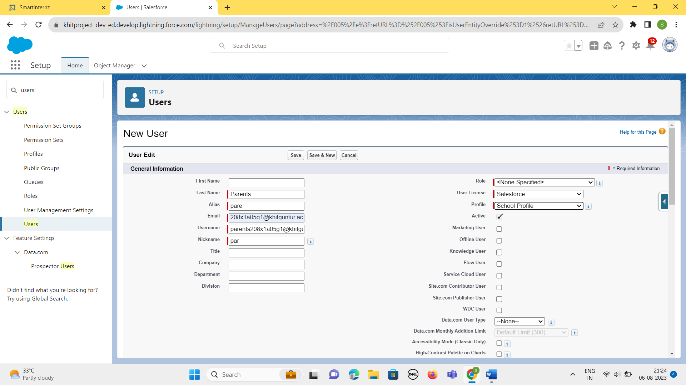

Similarly, we created two users -Teachers and Principals like below:

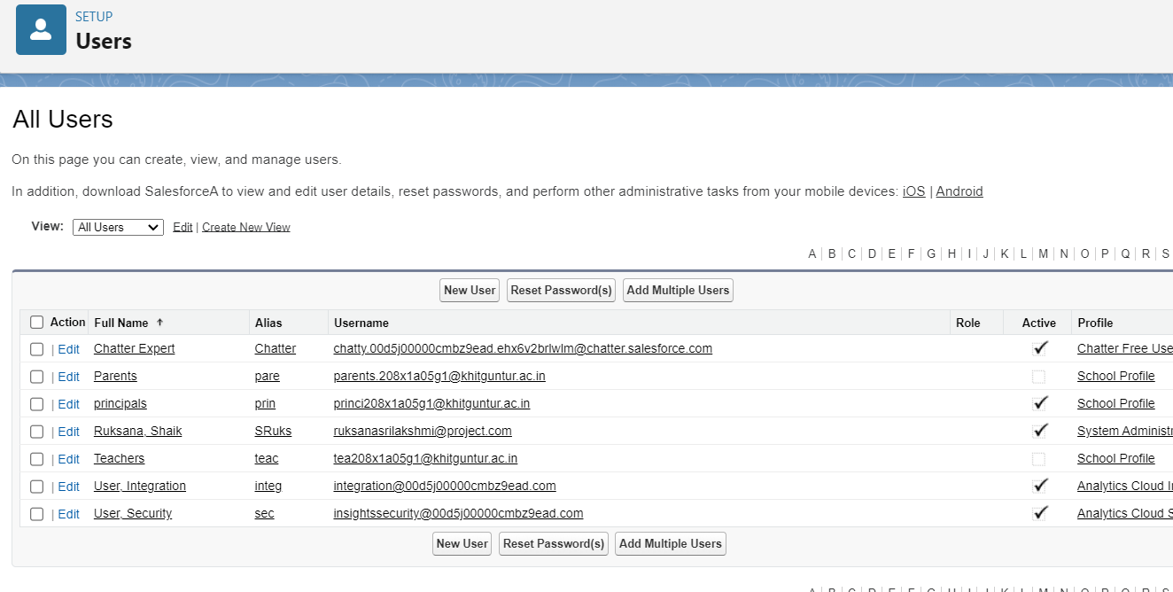



### **8.Permission Sets**

A permission set is a collection of settings and permissions that give users access to various tools and functions. Permission sets extend users' functional access without changing their profiles.

### Permission Sets 1:

1.From Setup, enter Permission Sets in the Quick Find box, then select Permission Sets.

2.Click New.

3.Give the name of the Permission set name as teacher permission.

4.Under the object settings give the view create and edit permissions to all 3 custom objects (By click open the object)

5.Click on manage assignment

6.Click on add assignment.

7.Click on Teacher (user), Next, Assign.

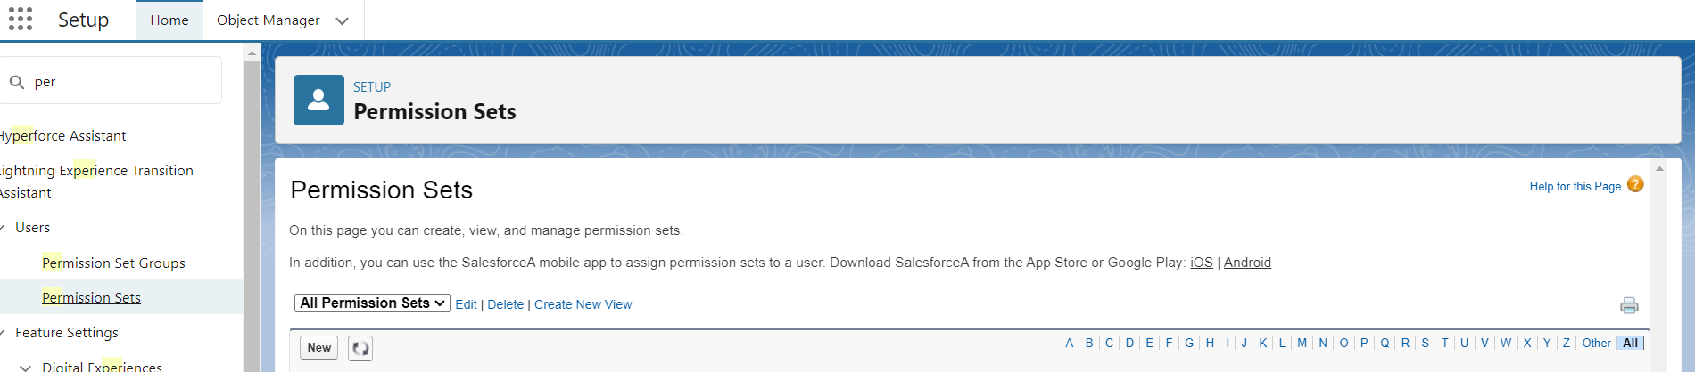

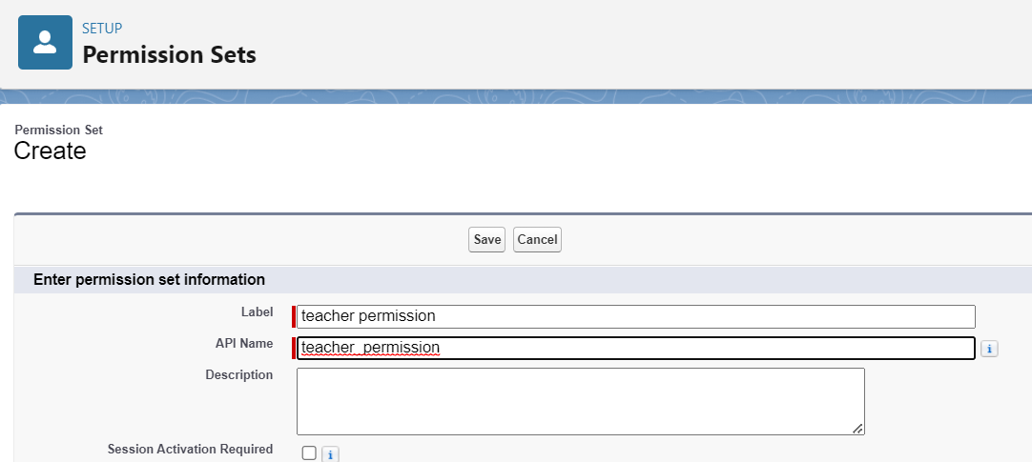

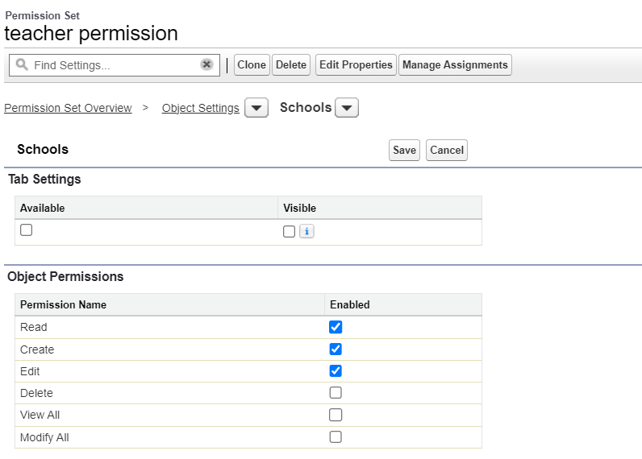

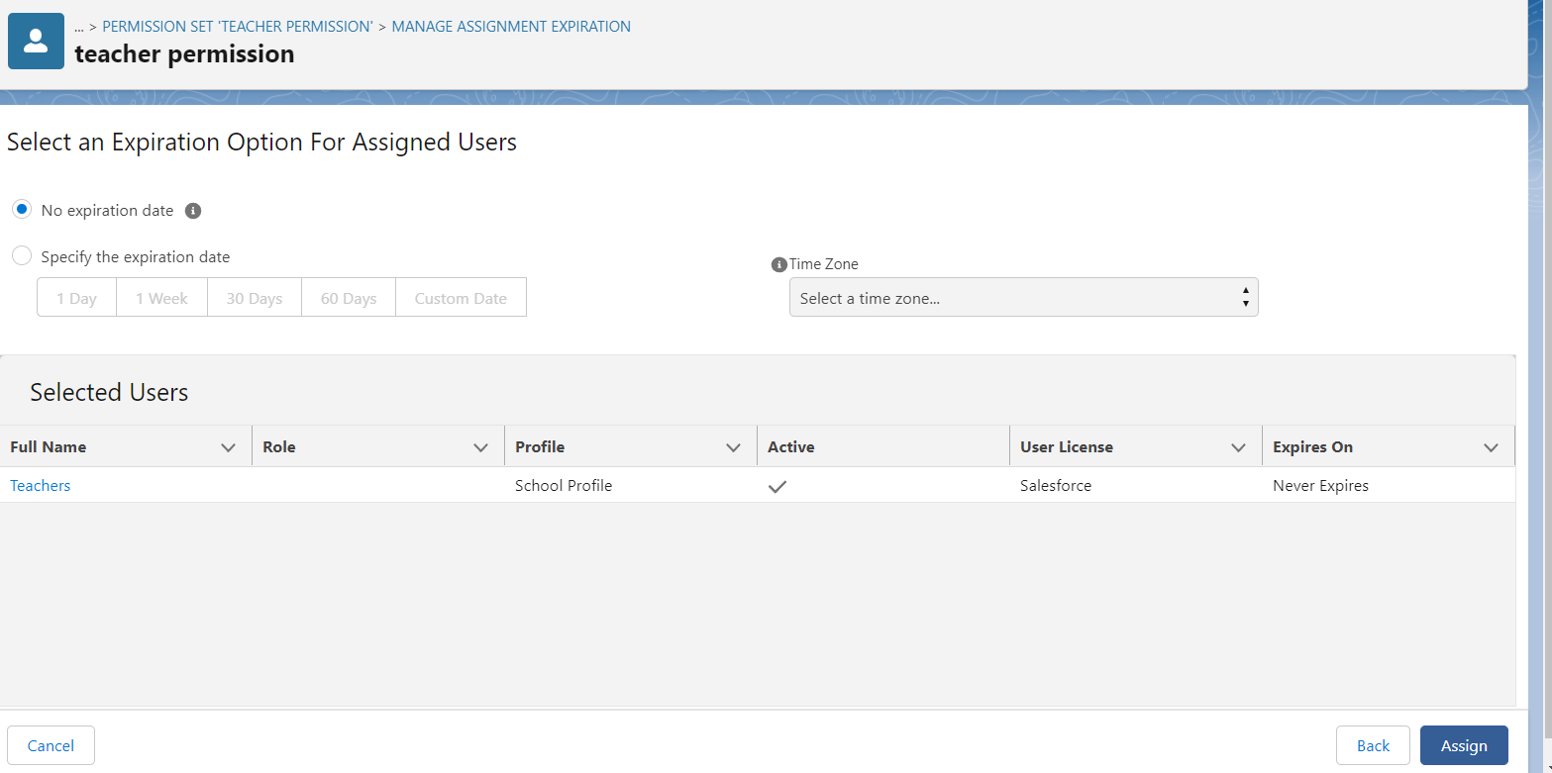

### Permission Sets 2:

Similarly, we create another permission set that is Principal permission.

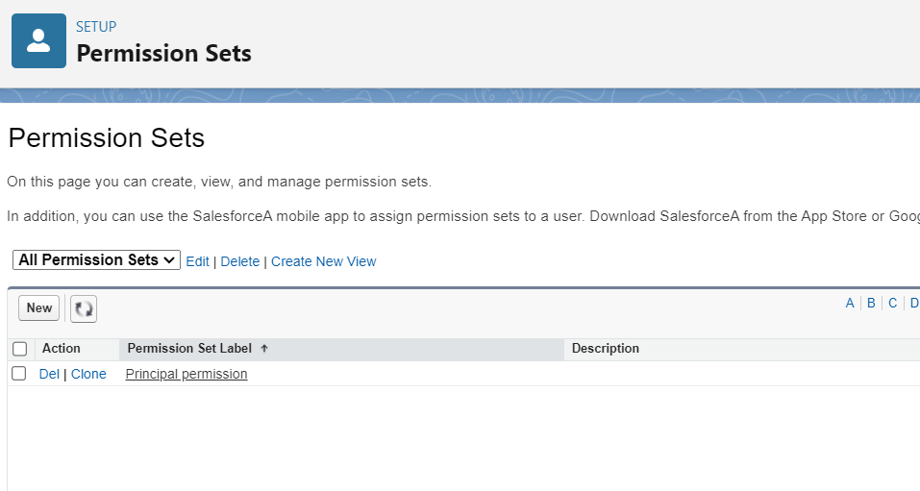

### **9.User Adoption**

### Create Record (School):

1.Click on App Launcher on left side of screen.

2.Search School Management App & click on it.

3.Click on Schools tab.

4.Click new button

5.Fill all School record details.

6.Click on Save Button

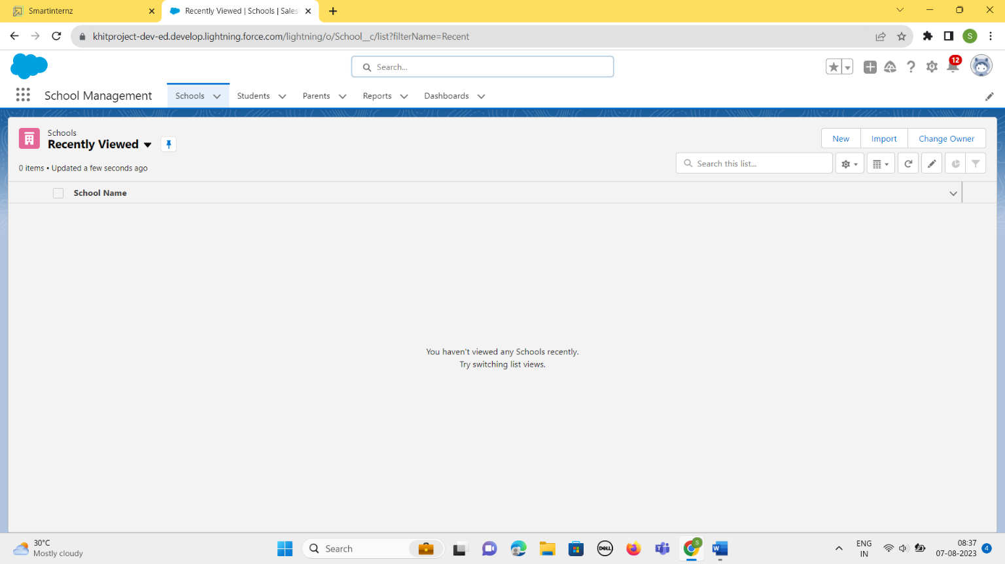



Clicking new, we have to fill the details of the school like School Name, Address, State, District, Phone Number, School Website.

This is displayed below:

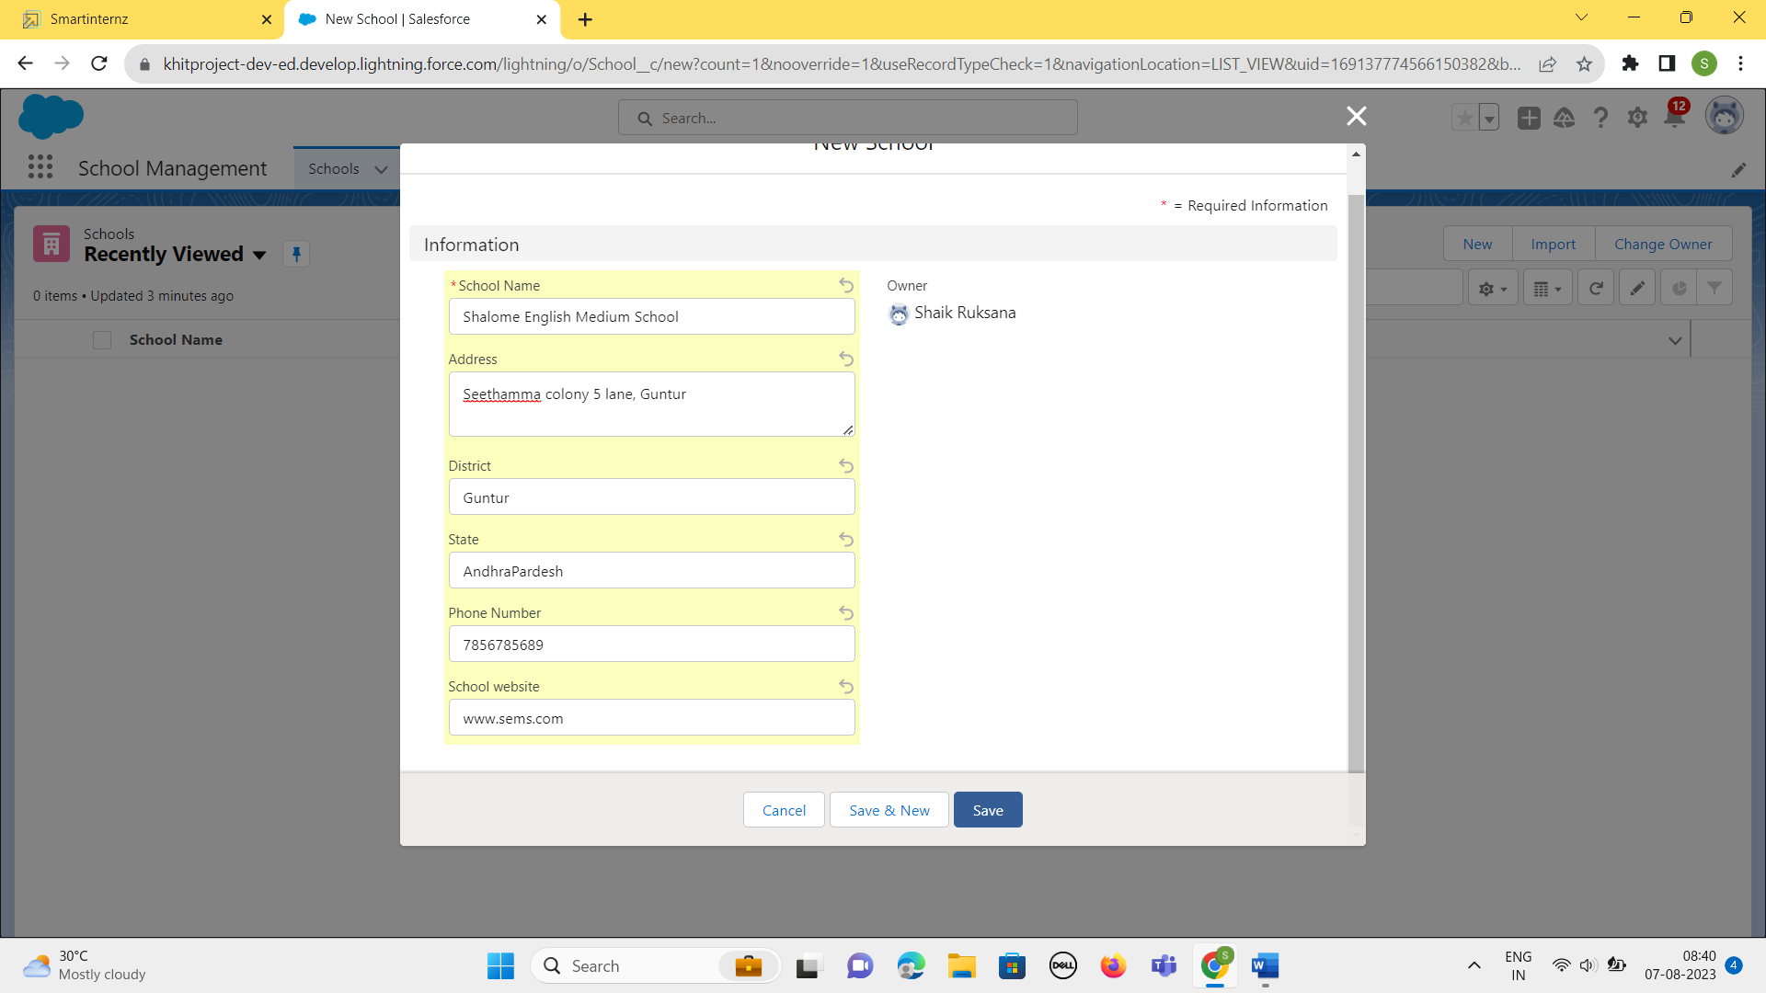

### View Record (School):

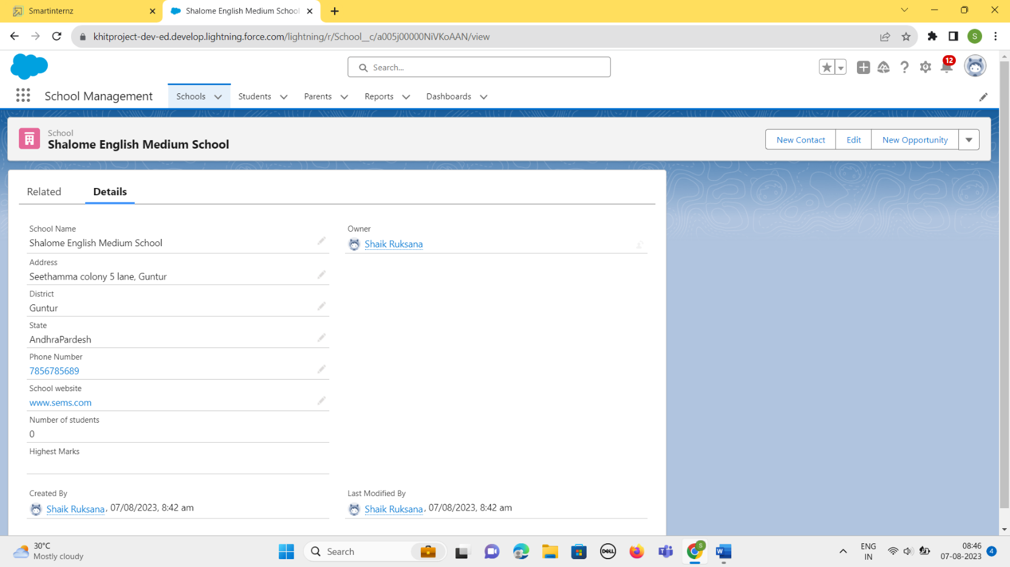

### Delete Record (School):

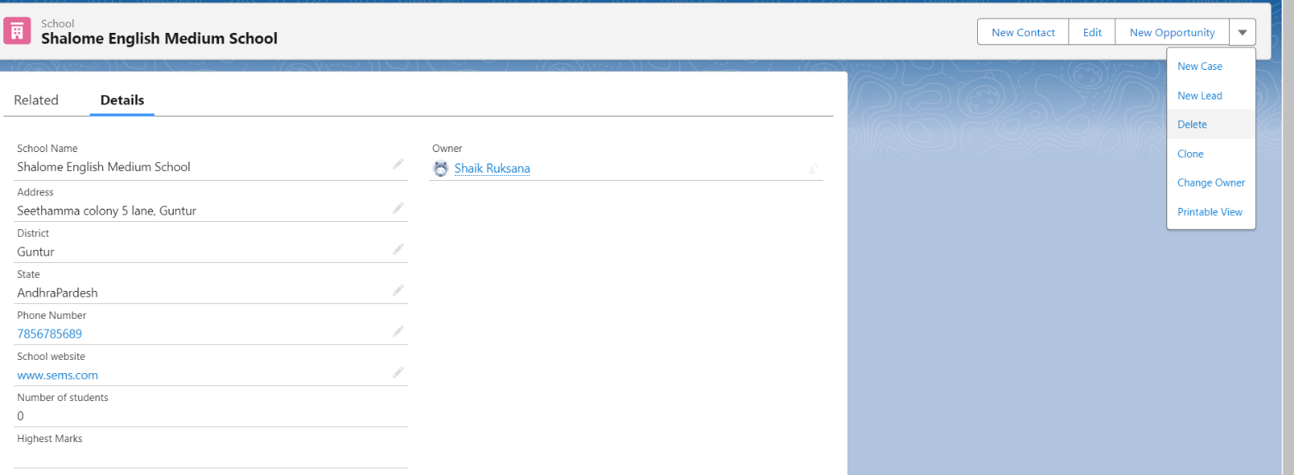



By Clicking it, The School named “*Shalome English Medium School* “ will be deleted . And it is not Visible.

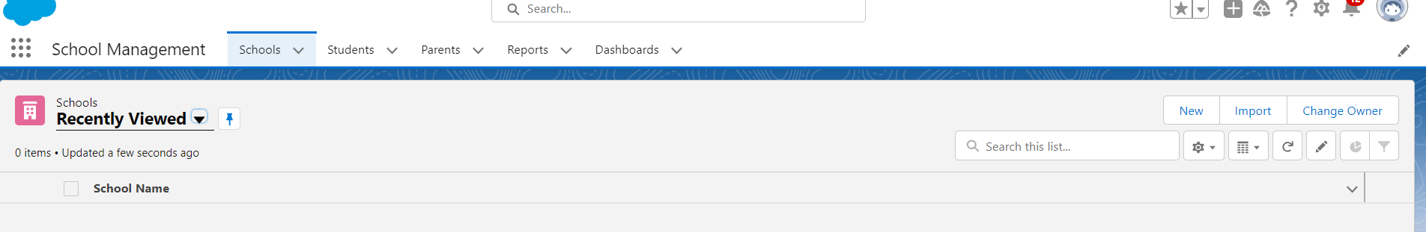

### **10.Reports**

Reports in Salesforce is a list of records that meet a particular criterion which gives an answer to a particular question. These records are displayed as a table that can be filtered or grouped based on any field.

### Create Report:

1.In School Management App click Reports tab.

2.Click New Report.

3.Select the report type as School with students and parents for the report.

4.Click start report.

5.Customize your report, then save and run

6.Give report name – Schools with Students Report

7.Click Save

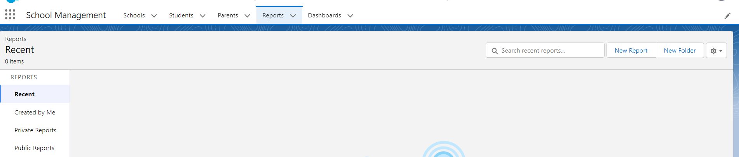



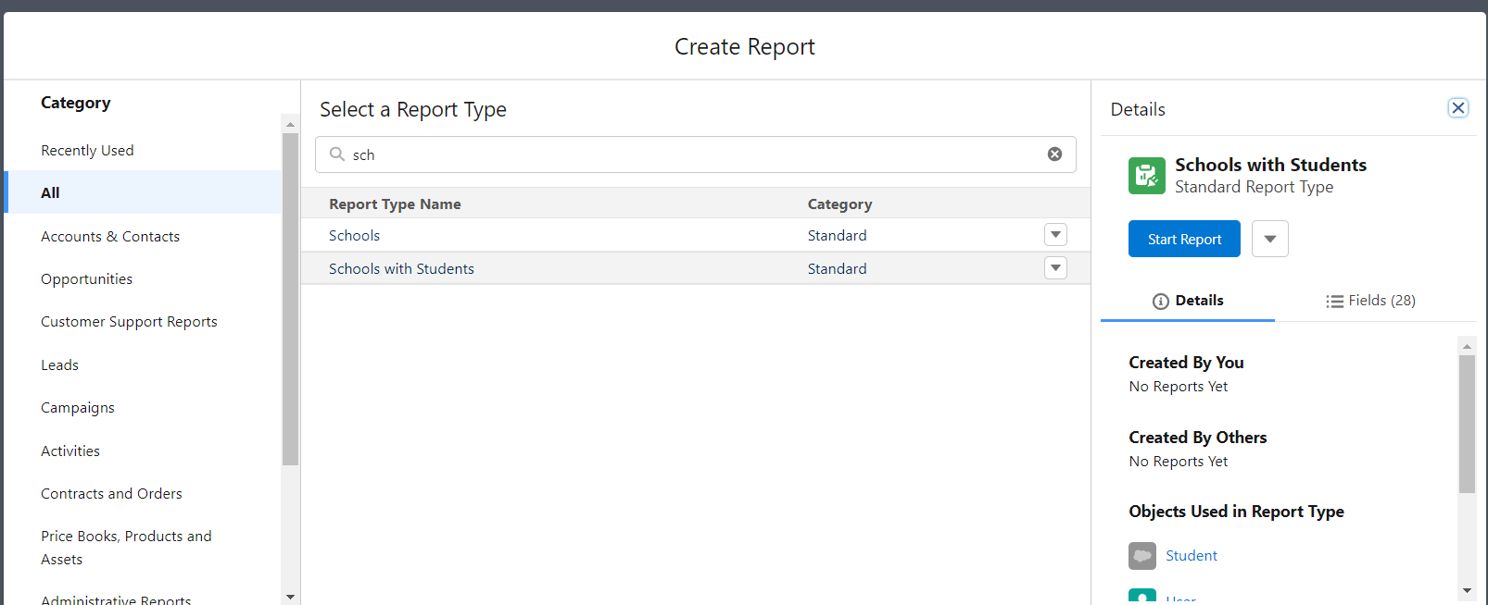



The following is the format of the Report for the school:

It contains *Outlines* and *Filters*

In Outlines tab we have- Group Rows, Group Columns.

In the Columns Tab, we have Columns like *School: School Name*, *Student: Student Name*

Now we have to save the report with the Report Name – “*Schools with Students Report”.* Click save & run at the top and save it as below: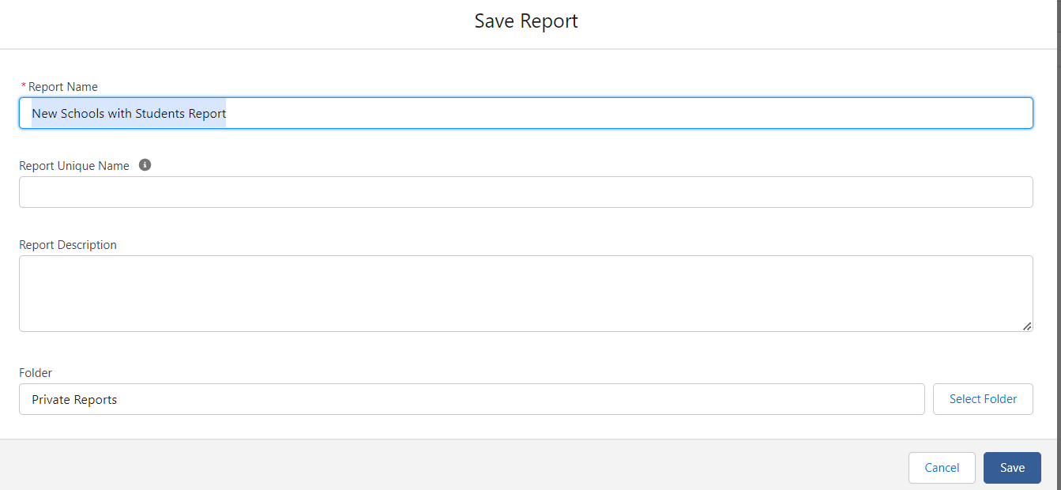



### View Report:

1.Click on App Launcher on left side of screen.

2.Search School Management App & click on it.

3.Click on Reports Tab.

4.Click on School with Students report and see records.



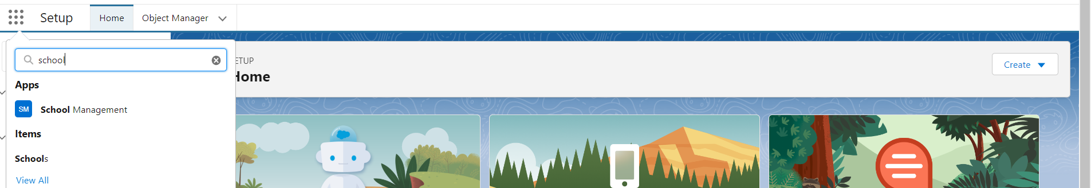



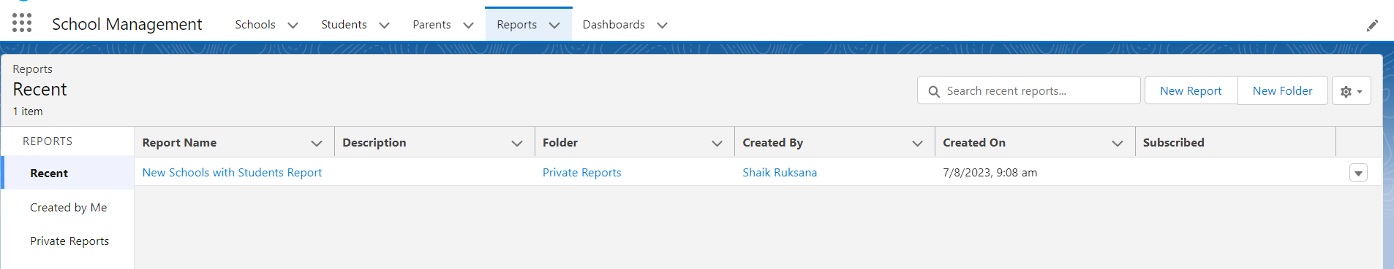



In this way, we have successfully created the *School Management App* and performed all the actions.

ADVANTAGES & DISADVANTAGES

**Advantages:**

1.Cloud-based

2.Integrated Ecosystem

3.Customizability

4.User-Friendly Interface

5.Security and Compliance

**Disadvantages:**

1.Cost

2.Learning Curve

3.Dependency on Salesforce

4.API Limitations

5.Data Ownership

6.Offline Access

7.Limited Customization in Low-Code Solutions

APPLICATIONS

1.Schools and K-12 Institutions

2.Colleges and Universities

3.Online Learning Platforms

4. Tutoring Centres and Coaching Institutes

5. Non-Profit Educational Initiatives

6.Training and Development Programs

7. Vocational Institutes

8. Special Education Programs

9. After-School Programs

10. Language Schools

CONCLUSION

In conclusion, the School Management Application developed on the Salesforce platform offers a comprehensive and efficient solution to streamline administrative tasks and improve communication within educational institutions. Through a user-friendly interface and automation features, the application simplifies attendance tracking, academic management, and examination processes.

FUTURE SCOPE

The School Management Application in Salesforce has a promising future scope, with several potential enhancements and improvements that can be implemented to further enhance its functionality and impact. Some future enhancements include:

1.Mobile Application

2.Artificial Intelligence Integration

3.Learning Management System (LMS) Integration

4.Parent-Teacher Conference Scheduling

5.Alumni Management

6.Financial Aid and Scholarship Management

7.Classroom IoT Integration

8.Gamification and Rewards

9.Virtual Reality (VR) and Augmented Reality (AR) Support

10.Predictive Analytics for Student Success

11.Multilingual Support

12.Voice Assistant Integration

*THANK YOU*

